CMC Precision Engineering Ltd is committed to ensuring the health, safety and welfare of its employees and sub-contracted staff, so far as is reasonably practicable. The organisation also fully accepts that it has a responsibility for other people who may be affected by its activities and will take steps to ensure that statutory duties are always met.

Each employee will be given the information, instruction, and training necessary for him or her to work in a safe manner. They will also be provided with the necessary PPE required to work safely relative to the work environment.

Risk assessments have been completed for each area and actions have been performed based on the findings to reduce the possibility of any incidents occurring.

It is the duty of management to ensure that all processes and work procedures are designed to take account of health and safety and are properly supervised at all times. This includes the regular maintenance of plant equipment to reduce as much as reasonably practical the risk involved with using the equipment.

Adequate arrangements will be made to enable employees to raise health and safety issues. Documents for reporting any near misses or injuries on site are available in the office and actions will be taken to mitigate the risk.

If in the event of a fire or any other significant incident there is a need for evacuation, all fire exits are well signed and kept clear.

CMC Precision Engineering Ltd provides toilets, washing facilities and drinking water to maintain a safe and hygienic working environment. These will be cleaned on a regular basis.

All members of staff have a responsibility to maintain a clean and tidy work environment.

To comply with its statutory and common law duties, the organisation has insurance against liability for death, injury, and/or disease suffered by any of its employees arising out of and in the course of employment, if caused by negligence and/or breach of statutory duty on the part of the organisation.

All employees are required, as part of their terms and conditions of employment, to co-operate with the organisation so that all statutory duties are complied with. The successful implementation of this policy requires total commitment from upper management down to the shopfloor. Each person has a legal duty to take reasonable care for his or her own health and safety and the health and safety of others who may be affected by his or her acts or omissions.

Full details of the organisation and arrangements for health and safety are set out in separate documents.

This policy statement, together with the associated organisational arrangements and procedures, will be monitored and subject to regular review to ensure that the objectives are achieved. It will be reviewed and, if necessary, revised to take account of changes in the organisation, business activities or legislation [EU Directives, Regulations and British Standards].

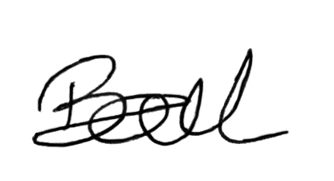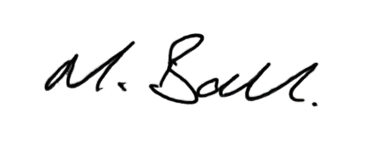

Kerry Ball Matthew Ball
Managing Director Director
CMC Precision Engineering Ltd CMC Precision Engineering Ltd

