CMC Precision Engineering Ltd is committed to the practice of responsible corporate behaviour.
Through its business practices the Company seeks to protect and promote the human rights and basic freedoms of all its employees and agents.
Further the Company is committed to protecting the rights of all of those whose work contributes to the success of the Company, including those employees and agents of suppliers to the Company.
The Company is also committed to eliminating bribery and corruption. It is essential that all employees and persons associated with the Company adhere to this policy and abstain from giving or receiving bribes of any form.
This policy is non-exhaustive, and all aspects of the Company’s business should be considered in the spirit of this policy.

Human Rights
The Company is vehemently opposed to the use of slavery in all forms; cruel, inhuman or degrading punishments; and any attempt to control or reduce freedom of thought, conscience and religion.
The Company will ensure that all its employees, agents and contractors are entitled to their human rights as set out in the Universal Declaration of Human Rights and the Human Rights Act 1998.
The Company will not enter into any business arrangement with any person, company or organisation which fails to uphold the human rights of its workers or who breach the human rights of those affected by the organisation’s activities.
Workers’ Rights
The Company is committed to complying with all relevant employment legislation and regulations. The Company regards such regulations and legislation as the minimum rather than the recommended standard.
No worker should be discriminated against on the basis of age, gender, race, sexual orientation, religion or beliefs, gender reassignment, marital status or pregnancy. All workers should be treated equally. Workers with the same experience and qualifications should receive equal pay for equal work.
No worker should be prevented from joining or forming a staff association or trade union, nor should any worker suffer any detriment as a result of joining, or failing to join, any such organisation.
Workers should be aware of the terms and conditions of their employment or engagement from the outset. In particular workers must be made aware of the wage that they receive, when and how it is to be paid, the hours that they must work and any legal limit which exists for their protection and any overtime provisions. Workers should also be allowed such annual leave, sick leave, maternity / paternity leave and such other leave as is granted by legislation as a minimum.
The Company does not accept any corporal punishment, harassment in any form, or bullying in any form.
Environmental Issues
The Company is committed to keeping the environmental impact of its activities to a minimum and as an absolute minimum, the Company will ensure that it meets all applicable environmental laws in whichever jurisdiction it may be operating.
Conflicts of Interest
The Company holds as fundamental to its success the trust and confidence of those with whom it deals, including clients, suppliers and employees. Conflicts of interest potentially undermine the relationship of the Company with its partners.
In order to help preserve and strengthen these relationships the Company has developed a Corporate Hospitality and Gifts Policy, which provide rules and guidelines concerning the conduct of its officers and employees aimed at minimising the possibility of conflicts of interest and at avoiding risks associated with bribery and corruption.
All officers, employees and representatives of the Company are expected to act honestly and within the law.

Information and Confidentiality
Information received by employees, contractors or agents of the Company will not be used for any personal gain, nor will it be used for any purpose beyond that for which it was given.
The Company will at all times ensure that it complies with all applicable requirements of data protection legislation (including, but not limited to, the Data Protection Act 2018) in force from time to time.

Suppliers and Partners
The Company expects all suppliers and partners to work towards and uphold similar ethical and moral standards.
The Company will investigate the ethical record of potential new suppliers before entering into any agreement. Further, the Company reserves the right to request information from suppliers regarding the production and sources of goods supplied.
The Company reserves the right to withdraw from any agreement or other arrangement with any supplier or partner who is found to have acted in contravention of the spirit or principles of this Ethical Policy.

Bribery and Corruption
The Company is fundamentally opposed to any acts of bribery and to the making of facilitation payments as defined by the Bribery Act 2010.
Employees and any other persons associated with the Company such as agents, subsidiaries and business partners are not permitted to either offer or receive any type of bribe and/or facilitation payment.
All employees are encouraged to report any suspicion of corruption or bribery within the Company to the Managing Director.
Should any employee or associated person be in doubt when receiving or issuing gifts and hospitality, he/she must refer to the Gift and Hospitality Policy available from the Main office.
The Company uses its reasonable endeavours to implement the guidance principles on bribery management that are published, from time to time, by Secretary of State in accordance with Section 9 of the Bribery Act 2010.
If an employee or associated person is found guilty of giving or receiving a bribe, he/she will be personally criminally liable and may be subject to disciplinary action.
Anyone found guilty of bribery, will be responsible for bearing any related remedial costs such as losses, court fees or expenses.

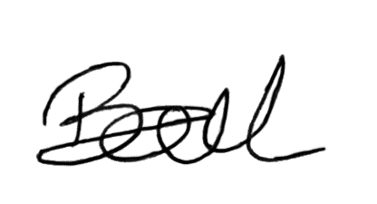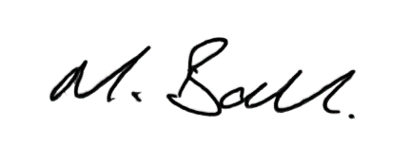

Kerry Ball Matthew Ball
Managing Director Director
CMC Precision Engineering Ltd CMC Precision Engineering Ltd

