Modern slavery is a crime resulting in an abhorrent abuse of the human rights of vulnerable workers. It can take various forms, such as slavery, servitude, forced or compulsory labour and human trafficking.
The Company has a zero-tolerance approach to modern slavery and is committed to acting ethically and with integrity and transparency in all of its business dealings and relationships and to implementing and enforcing effective systems and controls to ensure that modern slavery and human trafficking are not taking place anywhere within either its own business or in any of its supply chains, consistent with its obligations under the Modern Slavery Act 2015.
The Company also expects the same high standards from all of its suppliers, contractors and other business partners and, as part of its contracting processes, it includes specific prohibitions against the use of modern slavery and expects that its suppliers will in turn hold their own suppliers to the same standards.
Identifying potential victims of modern slavery can be a challenge because the crime can manifest itself in many different ways. There is a spectrum of abuse and it is not always clear at what point, for example, poor working practices and lack of health and safety awareness have become instances of human trafficking, slavery or forced labour in a work environment. In addition, some suppliers may go to great lengths to hide the fact that they are using slave labour. However, the Company accepts that it has a responsibility through its due diligence processes to ensure that workers are not being exploited, that they are safe, and that relevant employment, health and safety and human rights laws and standards are being adhered to, including freedom of movement and communications.
This policy applies to all individuals working for the Company or on the Company’s behalf in any capacity, including employees, directors, officers, agency workers, volunteers, agents, contractors, consultants and business partners.
Responsibility for the policy
The Managing Directors of CMC Precision Engineering Ltd have ultimate responsibility for ensuring that this policy complies with the Company’s legal and ethical obligations.
The Managing Director has day-to-day responsibility for implementing this policy, monitoring its use and effectiveness and auditing internal control systems and policies and procedures to ensure they are effective in preventing or remediating the risk of modern slavery and is also responsible for investigating allegations of modern slavery in the Company’s business or supply chains.
The Shop Floor Manager is responsible for ensuring that those reporting to them understand and comply with this policy.
Compliance
The prevention, detection and reporting of modern slavery in any part of the Company’s business or supply chains, whether in the UK or abroad, is the responsibility of all those working for the Company or under the Company’s control. You are required to avoid any activity that might lead to a breach of this policy.
If you believe or suspect a breach of or conflict with this policy has occurred or may occur, you must notify your line manager or report it to the Managing Director. You are encouraged to raise concerns about any issue or suspicion of modern slavery in any part of the Company’s business or supply chains as soon as possible. If you are unsure about whether a particular act, the treatment of workers or their working conditions within any of the Company’s supply chains constitutes any of the various forms of modern slavery, please raise it with your line manager. You can also contact the government’s Modern Slavery Helpline on 0800 0121 700 for further information and guidance on modern slavery.
The Company aims to encourage openness and will support anyone who raises genuine concerns in good faith under this policy, even if they turn out to be mistaken. The Company is committed to ensuring no one suffers any detrimental treatment or victimisation as a result of reporting in good faith their suspicion that modern slavery is or may be taking place in any part of its business or in any of its supply chains.
Training and communication
Regular training on this policy, and on the risk that the business faces from modern slavery in its supply chains, will be provided to staff as necessary, so that they know how to identify exploitation and modern slavery and how to report suspected cases.
The Company’s zero tolerance approach to modern slavery must be communicated to all suppliers, contractors and other business partners when entering into new or renewed contracts with them.
Breach of the policy

Any employee who breaches this policy will face disciplinary action, up to and including summary dismissal for gross misconduct.
The Company may terminate its commercial relationship with suppliers, contractors and other business partners if they breach this policy and/or are found to have been involved in modern slavery.

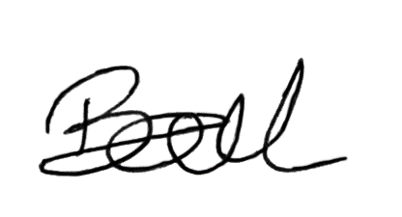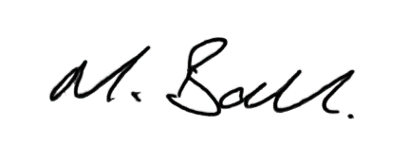

Kerry Ball Matthew Ball
Managing Director Director
CMC Precision Engineering Ltd CMC Precision Engineering Ltd

